P.E.S. College of Engineering
Nagsenvana, Chhatrapati Sambhajinagar.

Department of Computer Science and Engineering

1. Group Details
- Group Name:
- Group Members:
Sr. No. | Name of Student | Roll No.
1. | Sandesh Bansode | 49
2. | Syed Asimuddin | 52

Adaptive Traffic Signal Control Using Computer Vision

Problem Statement
Traditional traffic signals use fixed timings and cannot adapt effectively to changing traffic conditions. This may result in traffic congestion, long queues, and unnecessary waiting. The proposed system uses computer vision to analyze vehicle count, lane density, queue length, and emergency vehicles, and dynamically adjusts traffic-signal timings.

Target Users
Traffic management authorities, smart-city systems, and transportation planners.

3. Type of Project/Application
AI/ML Based / Computer Vision / Smart City

4. Requirement Gathering

Functional Requirements
- Detect and count vehicles from camera feeds.
- Calculate lane-wise traffic density.
- Estimate queue length.
- Detect emergency vehicles.
- Dynamically optimize traffic-signal timings.
- Simulate traffic conditions and signal control.

Non-Functional Requirements
- Accurate vehicle detection.
- Efficient processing.
- Reliable signal decisions.
- Scalable for multiple lanes.
- Real-time or near real-time operation.

Technology Stack Proposed
Python, YOLO, OpenCV, SUMO (Traffic Simulation).

The Adaptive Traffic Signal Control Using Computer Vision system uses camera feeds to analyze traffic conditions. YOLO is used for vehicle detection, while OpenCV processes the video and extracts traffic information such as vehicle count, lane density, and queue length. Emergency vehicles are also detected.
The collected information is provided to an optimization algorithm that dynamically determines suitable traffic-signal timings. SUMO is used to simulate the traffic environment and evaluate the effectiveness of the proposed system.

5. System Architecture Diagram

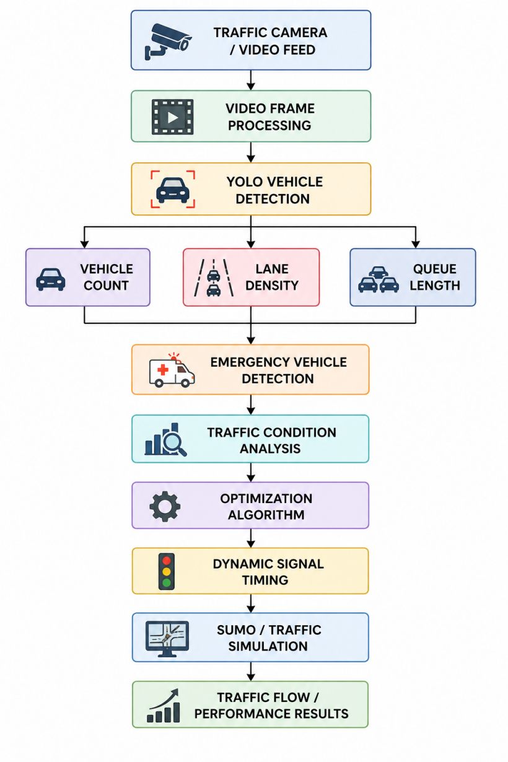

6. Number of Modules
Module No. | Module Name | Brief Description
1 | Vehicle Detection | Detects and counts vehicles using YOLO.
2 | Traffic Analysis | Determines density and queue length.
3 | Emergency Detection | Detects emergency vehicles.
4 | Signal Optimization | Calculates adaptive signal timings.
5 | Traffic Simulation | Simulates signals and traffic using SUMO.

7. Expected Outcomes
- Reduced traffic congestion and waiting time.
- Adaptive traffic-signal control based on traffic conditions.
- Accurate vehicle and density detection.
- Emergency-vehicle prioritization.
- Simulation-based evaluation of the proposed system.

8. References / Inspiration
- YOLO – Object Detection
- OpenCV – Computer Vision
- Python
- SUMO – Traffic Simulation
- Intelligent Traffic Management Systems

Submitted To
- Name of Project Coordinator: Prof S.K.Shewale
- Date of Submission: 12/08/2026

